Travel Planning Application – MERN Project Report

Project Details
Field | Details
Institution | [College / Institution Name], Department of Computer Science and Engineering
Academic year | [20XX – 20XX]
Subject | [Subject name]
Project title | Travel Planning Application
Problem statement | Build a MERN-based travel planning application that builds itineraries and manages travel expenses
Technology stack | MongoDB, Express.js, React.js, Node.js (MERN)
Project designation | Hackathon / Academic mini-project
Team name | [Team Name]
Team members | [Student Name 1] – [Roll No.];  [Student Name 2] – [Roll No.];  [Student Name 3] – [Roll No.]
Faculty guide | [Faculty Name, Designation]

Abstract
The Travel Planning Application is a MERN-based web application that lets a traveller build a day-wise itinerary and track the expenses of every trip in one place. Trip plans usually live in chat messages, spreadsheets and paper notes, so the full plan is hard to see and overspending is noticed only after the trip.
The system manages five kinds of records: destinations, dates, activities, budgets and expenses. MongoDB stores them, Node.js and Express.js provide a REST API, and React.js provides the user interface. The API supports the main operations the project requires: adding, viewing, updating and deleting records. Authentication uses JSON Web Tokens, and role-based access separates the traveller (user) from the administrator, who manages the shared destination catalogue and user accounts.
For every trip the application compares the total of the recorded expenses with the planned budget and shows the remaining balance, in total and per category, so that an overrun is visible immediately.
The expected outcome is a working full-stack prototype that demonstrates the MERN stack, CRUD operations on MongoDB, REST APIs, a React frontend, authentication with role-based access, and a clear display of project information and results. The sample values in this report are illustrative and are not measurements from a running system.
Keywords: travel planning, itinerary, expense tracking, budget, MERN stack, MongoDB, Express.js, React.js, Node.js, REST API, JWT, role-based access.

1. Introduction

1.1 Background of Travel Planning
A trip needs many linked decisions: where to go, on which dates, what to do each day and how much to spend. Travellers collect this information from many sources and then have to keep it consistent as plans change. A destination change moves the dates, the dates move the activities, and the activities change the money needed.

1.2 Problems with Manual Planning
- Scattered information: tickets, bookings and ideas sit in different chats, notes and files.
- No day-wise view: there is no single place that shows what happens on each day.
- Unnoticed overspending: expenses are added up only after the trip, when nothing can be changed.
- Forgotten expenses: small payments are not written down at the time they are made.
- Hard to update: changing one date or activity means rechecking everything that depends on it.

1.3 Existing and Proposed Approach
Aspect | Manual / spreadsheet planning | Proposed application
Itinerary | Free text or rows in a sheet | Activities stored per trip and shown day by day
Budget | One total kept in the head or in a cell | Total budget plus a limit per category
Expenses | Added up by hand | Recorded one by one and compared with the budget automatically
Access | One file shared by copy | Personal account with login; roles for user and admin
Changes | Manual rechecking | Update a record; summary recalculates

1.4 Motivation and Choice of the MERN Stack
The project turns trip planning into a small, inspectable web application that shows the full path from a browser form to a database record. The MERN stack suits this: JavaScript is used in the database queries, server and browser, data travels as JSON from end to end, and MongoDB's document model fits records such as trips and activities that have nested and optional fields.

2. Problem Statement

2.1 Official Problem Statement
Build a MERN-based travel planning application that builds itineraries and manages travel expenses.
The system should manage destination, date, activity, budget and expense data using MongoDB. React provides the user interface, while Node.js and Express.js handle the backend APIs. The system should support the main operations required for the project, including adding, viewing, updating and managing the relevant records.

2.2 Problem Definition
Given a registered traveller who plans trips to destinations on specific dates, let the traveller (a) create a trip with a destination, dates and a total budget, (b) plan activities for the days of the trip, (c) set budget limits and record expenses as they happen, and (d) see at any time how much has been spent against the budget. Access to every record must be limited to its owner, and shared catalogue data must be managed only by an administrator.

2.3 Input, Processing and Output
Aspect | Description
Input | Registration and login details; destination details (name, country, description); trip details (title, destination, start date, end date, total budget); activity details (title, date, time, location, category, estimated cost); budget limit per category; expense details (category, amount, date, description, payment mode).
Processing | Validate every request; authenticate the user from the JWT; check role and ownership; store, read, update or delete the record in MongoDB; add up expenses per trip and per category; compare the sum with the budget.
Output | Itinerary grouped by day; list of trips, activities and expenses; budget summary with spent, remaining and over-budget categories; clear error messages for invalid or unauthorised requests.

2.4 Rules the System Must Follow
- The end date of a trip must not be earlier than its start date.
- An activity date must fall within the dates of its trip.
- Amounts, budgets and estimated costs must be positive numbers (a budget may be zero).
- A user can read and change only the trips, activities, budgets and expenses of their own account.
- Only an administrator can add, change or remove destinations in the shared catalogue and manage user accounts.
- Deleting a trip also deletes its activities, budgets and expenses.
- An invalid request is rejected with a message and leaves the stored data unchanged.

3. Objectives
The project pursues six objectives. Each is tied to something that can be demonstrated and checked.
No. | Objective | How it is demonstrated
1 | Demonstrate MERN stack development | One application in which React, Express, Node.js and MongoDB work together through JSON.
2 | Implement CRUD operations using MongoDB | Create, read, update and delete for destinations, trips, activities, budgets and expenses through Mongoose models.
3 | Build REST APIs using Node.js and Express.js | Resource-based endpoints with correct HTTP methods and status codes (see the API table in Chapter 8).
4 | Develop the frontend using React.js | Pages and components for login, trips, itinerary, budget and expenses, with state updates without page reloads.
5 | Implement authentication and role-based access where required | Registration and login with hashed passwords, JWT-protected routes, user and admin roles, per-user data ownership.
6 | Display project information and results clearly | Day-wise itinerary view and a budget summary showing spent, remaining and over-budget categories.

Expected Learning Outcomes
By completing the project the team should be able to (a) model travel data as MongoDB collections and relations, (b) design and secure a REST API, (c) build a React interface that talks to that API, and (d) explain how a request travels from the browser to the database and back.

4. Scope and Limitations

4.1 Scope
- Account management: registration, login and two roles (user, admin).
- Destination catalogue: records for destinations, maintained by the admin and chosen by users.
- Trip and itinerary management: trips with dates, and activities planned per day.
- Budget management: a total budget per trip and optional limits per category.
- Expense management: expenses recorded against a trip, with category and payment mode.
- Summary and reports: spent, remaining and over-budget figures per trip and per category.
- Web interface built in React and served by a REST API.

4.2 Limitations
- The application is an academic prototype, not a production booking platform.
- It does not book tickets or hotels and does not process payments.
- All amounts are in one currency per trip; no live currency conversion.
- Each trip has one main destination; trips with several destinations are future work.
- Dates are stored as calendar dates; time zones are not modelled.
- Data is entered by the user; no live prices, maps or weather are fetched.
- The sample results in this report are illustrative until the prototype is run.

4.3 Boundaries
Group expense splitting, map integration, receipt upload and recommendation features are kept out of the first version and appear as future scope in Chapter 13, so the report stays focused on the five required data types and the MERN stack.

5. Major Features
Each feature below is mapped to the part of the MERN stack that realises it.
Feature | Description | MERN component
Registration and login | Create an account and sign in; the server returns a JWT used on later requests. | React forms; Express auth routes; User collection
Role-based access | Users manage their own trips; admins also manage destinations and accounts. | Express middleware; role field in User
Destination catalogue | Browse and search destinations; admin adds, edits and removes them. | Destination collection; admin-only routes
Trip management | Create, view, update and delete trips with destination, dates and total budget. | Trip collection; React trip list and form
Itinerary builder | Add activities to the days of a trip and view the plan day by day. | Activity collection; React itinerary page
Budget planning | Set a total budget and optional limits per category. | Budget collection; budget form
Expense tracking | Record, edit and delete expenses with category, amount, date and payment mode. | Expense collection; expense form and list
Budget summary | Spent, remaining and over-budget categories, shown as figures and a chart. | MongoDB aggregation; React summary page
Validation and messages | Invalid input is rejected with a clear message; stored data stays unchanged. | Server-side validation; React error display
Feature interaction. A trip links a user to a destination. Activities, budgets and expenses all refer to the trip, so the itinerary and the budget summary always read from the same records and a change made in one place shows up everywhere on the next load.

6. Functional Requirements
Requirements are grouped by module. Each identifier is used in the test cases of Chapter 12.
ID | Requirement | Role
FR-A1 | Register with name, email and password; the password is stored only as a hash. | Public
FR-A2 | Log in with email and password and receive a JWT. | Public
FR-A3 | Reject any protected request without a valid token. | All
FR-D1 | List and search destinations. | User, Admin
FR-D2 | Add, update and delete destinations. | Admin
FR-T1 | Create a trip with title, destination, start date, end date and total budget. | User
FR-T2 | List the user's own trips and open one trip in full. | User
FR-T3 | Update or delete a trip; deleting also removes its activities, budgets and expenses. | User
FR-C1 | Add an activity to a trip with title, date, time, location, category and estimated cost. | User
FR-C2 | View the itinerary of a trip grouped by day. | User
FR-C3 | Update or delete an activity. | User
FR-B1 | Set the total budget of a trip and optional limits per category. | User
FR-E1 | Add an expense to a trip with category, amount, date, description and payment mode. | User
FR-E2 | List, update and delete expenses of a trip. | User
FR-S1 | Show spent, remaining and per-category totals for a trip. | User
FR-S2 | Mark a category or trip as over budget when spending exceeds the limit. | User
FR-M1 | List user accounts and change a user's role or remove an account. | Admin

6.1 Detailed Requirement Notes
Input handling. The server validates every request body: required fields must be present, dates must be valid, the end date must not precede the start date, and amounts must be positive numbers. The React forms repeat the main checks for quicker feedback, but the server is the authority.
Ownership. Every trip, activity, budget and expense belongs to one user through the trip. A request for a record that belongs to another user returns 404, so the existence of other users' records is not revealed.
Output derivation. The amount spent is the sum of the expenses of a trip. Remaining is total budget minus spent. A category is over budget when its spent amount is greater than its limit, and the trip is over budget when spent is greater than the total budget.
Traceability. Every requirement identifier appears in at least one test case in Chapter 12.

7. Non-Functional Requirements and System Workflow
Requirement | Description
Performance | Each request reads or writes a few documents; queries by trip id use an index, and the summary is one MongoDB aggregation per trip.
Security | Passwords are hashed; every protected route needs a valid JWT; role and ownership are checked on the server; secrets stay in environment variables.
Usability | Simple forms, a day-wise itinerary and plain-language error messages.
Reliability | Server-side validation and consistent status codes; an invalid request leaves the stored data unchanged.
Scalability | The API is stateless because identity travels in the token, so it can be run as several instances; MongoDB is scaled separately.
Maintainability | Separate folders for models, routes, controllers and middleware; the budget calculation lives in one function.
Responsiveness | React updates the page from API responses without a full reload, and the layout adapts to phone width.
Portability | Runs on any machine with Node.js and MongoDB, either local or MongoDB Atlas.

7.1 System Workflow
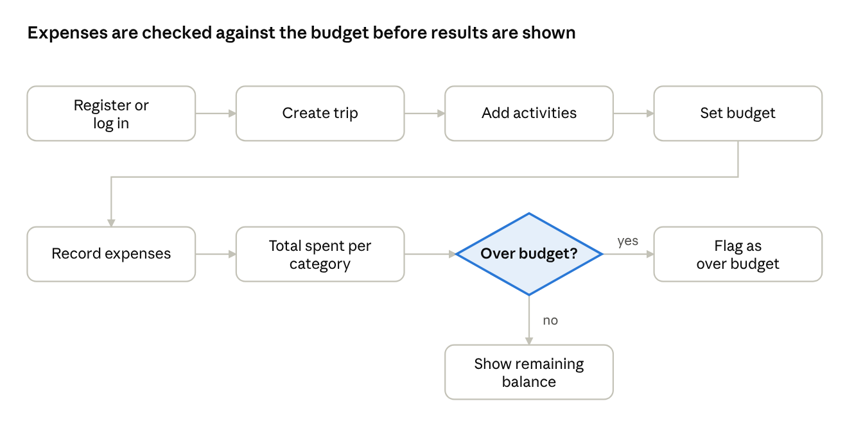
user workflow · 7 steps, 1 decision
A user signs in, plans the trip, and then repeats the expense steps as money is spent. The check against the budget decides what the summary page shows.
Stage | Explanation
1. Register or log in | The server checks the credentials and returns a JWT; the browser sends it with later requests.
2. Create trip | Title, destination, dates and total budget are validated and stored in the Trip collection.
3. Add activities | Each activity is stored with its trip, date and estimated cost; the itinerary groups them by day.
4. Set budget | Optional limits per category are stored in the Budget collection.
5. Record expenses | Each payment is stored in the Expense collection with category, amount and date.
6. Total spent per category | An aggregation adds up the expenses of the trip by category.
7. Compare with budget | Spent is compared with each category limit and with the total budget.
8. Show result | An over-budget category or trip is flagged; otherwise the remaining balance is shown.

8. System Design

8.1 Architecture
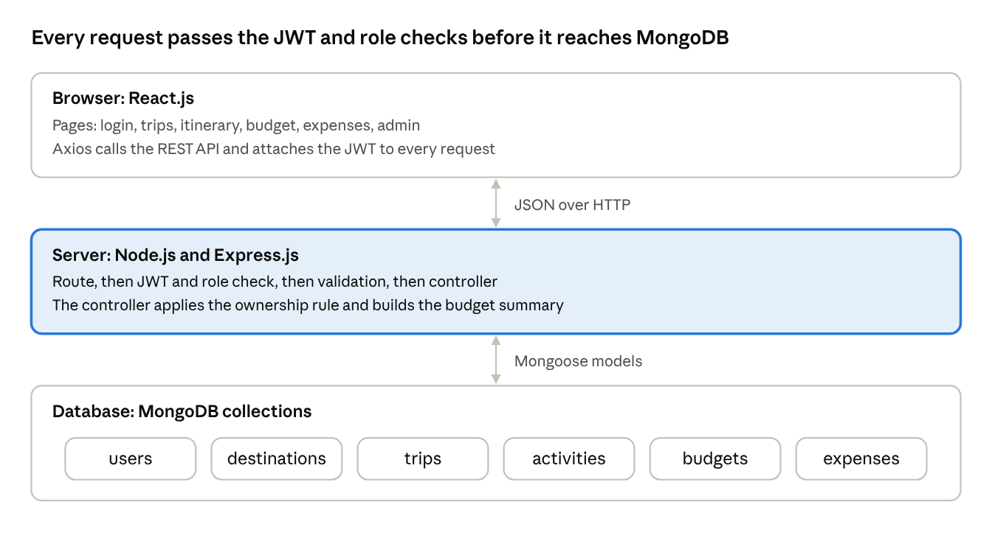
system architecture · 3 layers
The browser never talks to MongoDB. All data passes through the Express API, which checks the token, the role and the ownership of the record before a controller uses a Mongoose model to read or write the database.

8.2 Database Design
Six collections hold the data. Expense and activity categories come from one fixed list: Transport, Stay, Food, Sightseeing, Shopping and Other. Payment mode is one of cash, card, UPI or other.
Collection | Main fields | References
users | name, email (unique), passwordHash, role (user or admin), createdAt | None
destinations | name, country, description, bestSeason | createdBy refers to users
trips | title, startDate, endDate, totalBudget, currency, status (planned, ongoing or completed) | user refers to users; destination refers to destinations
activities | title, date, startTime, location, category, estimatedCost, notes | trip refers to trips
budgets | category, limit (one per trip and category) | trip refers to trips
expenses | category, amount, date, description, paymentMode | trip refers to trips; activity (optional) refers to activities
A trip belongs to one user and one destination. Activities, budgets and expenses belong to a trip, so deleting a trip removes them too. Records are linked by ObjectId references rather than embedded, because expenses and activities grow without a fixed limit and are queried on their own.

8.3 REST API
Method | Endpoint | Purpose | Access
POST | /api/auth/register | Create an account | Public
POST | /api/auth/login | Log in and receive a JWT | Public
GET | /api/auth/me | Return the current user | User, Admin
GET | /api/destinations | List and search destinations | User, Admin
POST | /api/destinations | Add a destination | Admin
PUT | /api/destinations/:id | Update a destination | Admin
DELETE | /api/destinations/:id | Delete a destination | Admin
GET | /api/trips | List the user's own trips | User
POST | /api/trips | Create a trip | User
GET | /api/trips/:id | Read one trip | User
PUT | /api/trips/:id | Update a trip | User
DELETE | /api/trips/:id | Delete a trip with its activities, budgets and expenses | User
GET | /api/trips/:id/activities | Itinerary ordered by date and time | User
POST | /api/trips/:id/activities | Add an activity | User
PUT | /api/activities/:id | Update an activity | User
DELETE | /api/activities/:id | Delete an activity | User
GET | /api/trips/:id/budgets | Read category limits | User
PUT | /api/trips/:id/budgets | Set category limits | User
GET | /api/trips/:id/expenses | List expenses | User
POST | /api/trips/:id/expenses | Add an expense | User
PUT | /api/expenses/:id | Update an expense | User
DELETE | /api/expenses/:id | Delete an expense | User
GET | /api/trips/:id/summary | Spent, remaining and per-category totals | User
GET | /api/admin/users | List user accounts | Admin
PUT | /api/admin/users/:id | Change a user's role | Admin
DELETE | /api/admin/users/:id | Remove an account | Admin
The API answers with 200 (success), 201 (created), 400 (invalid input), 401 (not logged in), 403 (role not allowed), 404 (not found or not owned) and 409 (duplicate email).

9. Technologies Used
The stack follows the MERN pattern named in the problem statement. Supporting libraries are listed with the job each one does.
Layer | Technology | Purpose in this project
Database | MongoDB | Stores users, destinations, trips, activities, budgets and expenses as documents.
Database access | Mongoose | Defines schemas, validation rules and references, and runs queries and aggregations.
Backend | Node.js | Runs the JavaScript server.
Backend | Express.js | Defines the REST routes and middleware.
Security | bcryptjs | Hashes passwords before they are stored.
Security | jsonwebtoken | Creates and verifies JWTs.
Backend support | cors, dotenv | Allows the React app to call the API; loads settings and secrets from a .env file.
Frontend | React.js | Builds the interface from components and keeps page state.
Frontend | React Router | Moves between pages and protects pages that need a login.
Frontend | Axios | Sends API requests and adds the JWT header.
Frontend | Recharts | Draws the budget-versus-spent chart on the summary page.
Testing | Postman, Jest with Supertest | Tries the API by hand and automates API tests.
Why this stack. One language runs in the browser, on the server and in the database shell, and data travels as JSON from end to end, so no format conversion is needed. MongoDB needs no fixed table design in advance, which suits a project whose fields may change during development.

10. System Implementation
The project is split into a server folder (Express API) and a client folder (React app). The excerpts below are abridged and show the intended design of the prototype.

10.1 Project Structure
travel-planner/
server/
config/db.js # mongoose.connect(process.env.MONGO_URI)
models/ # User, Destination, Trip, Activity, Budget, Expense
middleware/auth.js # protect (JWT) and allow (role)
controllers/ # auth, destination, trip, activity, budget, expense, admin
routes/ # one router file per resource
server.js # app setup, routes, error handler
.env # MONGO_URI, JWT_SECRET, PORT
client/
src/
api.js # Axios instance with the JWT header
context/AuthContext.jsx
pages/ # Login, Register, Trips, TripDetail, Summary, Admin
components/ # TripForm, ActivityForm, ExpenseForm, BudgetTable
App.jsx # routes and protected routes

10.2 Trip Model (Mongoose)
const tripSchema = new mongoose.Schema({
user: { type: mongoose.Schema.Types.ObjectId, ref: 'User', required: true },
title: { type: String, required: true, trim: true },
destination: { type: mongoose.Schema.Types.ObjectId, ref: 'Destination', required: true },
startDate: { type: Date, required: true },
endDate: {
type: Date,
required: true,
validate: {
validator: function (v) { return v >= this.startDate; },
message: 'endDate must not be before startDate'
}
},
totalBudget: { type: Number, min: 0, default: 0 },
currency: { type: String, default: 'INR' },
status: { type: String, enum: ['planned', 'ongoing', 'completed'], default: 'planned' }
}, { timestamps: true });
The date validator runs on create and on save(). Update routes therefore load the trip, change its fields and call save(), so the same check applies.

10.3 Authentication and Role Middleware
// middleware/auth.js
const jwt = require('jsonwebtoken');
exports.protect = (req, res, next) => {
const header = req.headers.authorization || '';
const token = header.startsWith('Bearer ') ? header.slice(7) : null;
if (!token) return res.status(401).json({ message: 'Not authenticated' });
try {
req.user = jwt.verify(token, process.env.JWT_SECRET); // { id, role }
next();
} catch {
res.status(401).json({ message: 'Invalid or expired token' });
}
};
exports.allow = (...roles) => (req, res, next) =>
roles.includes(req.user.role) ? next() : res.status(403).json({ message: 'Forbidden' });

// routes/destinations.js
router.get('/', protect, listDestinations);
router.post('/', protect, allow('admin'), createDestination);
router.put('/:id', protect, allow('admin'), updateDestination);
router.delete('/:id', protect, allow('admin'), deleteDestination);

10.4 Budget Summary (Express controller)
// GET /api/trips/:id/summary
exports.tripSummary = async (req, res) => {
const trip = await Trip.findOne({ _id: req.params.id, user: req.user.id });
if (!trip) return res.status(404).json({ message: 'Trip not found' });
const byCategory = await Expense.aggregate([
{ $match: { trip: trip._id } },
{ $group: { _id: '$category', spent: { $sum: '$amount' } } }
]);
const spent = byCategory.reduce((sum, c) => sum + c.spent, 0);
res.json({
totalBudget: trip.totalBudget,
spent,
remaining: trip.totalBudget - spent,
overBudget: spent > trip.totalBudget,
byCategory
});
};
The ownership rule is the user: req.user.id part of the query: a trip that belongs to someone else is simply not found.

10.5 React Component (abridged)
function ExpenseForm({ tripId, onAdded }) {
const [form, setForm] = useState({ category: 'Food', amount: '', date: '', description: '' });
const [error, setError] = useState('');
const submit = async (e) => {
e.preventDefault();
try {
const { data } = await api.post(`/trips/${tripId}/expenses`, {
...form, amount: Number(form.amount)
});
onAdded(data); // parent refreshes list and summary
setForm({ ...form, amount: '', description: '' });
setError('');
} catch (err) {
setError(err.response?.data?.message || 'Could not save the expense');
}
};
// render: <form onSubmit={submit}> with category, amount, date, description inputs
}
Request path. The form calls api.post; Axios adds the JWT; Express runs protect, validation and the controller; Mongoose writes the document to MongoDB; the controller returns JSON; React updates its state and the list and summary are redrawn without a page reload.

11. Results
Sample / demonstration results. The scenario below uses hypothetical data. The figures were worked out from the rules in Chapter 6 and show what the itinerary and summary pages are designed to display; they are not measurements from a running system. All amounts are in INR.

11.1 Sample Trip
Trip: "Goa Getaway", 5 days, total budget 40,000. The itinerary page lists the activities day by day:
Day | Activity | Category | Estimated cost
1 | Arrival and hotel check-in | Transport | 4,000
2 | Baga and Calangute beaches | Sightseeing | 600
3 | Fort Aguada and Old Goa churches | Sightseeing | 900
4 | Water sports at Candolim | Sightseeing | 1,800
5 | Anjuna flea market, then return | Shopping | 2,000

11.2 Budget Summary
Category limits add up to the total budget of 40,000. After the expenses are recorded, the summary page shows:
Category | Budget limit | Spent | Remaining | Status
Transport | 12,000 | 11,200 | 800 | Within budget
Stay | 14,000 | 14,500 | −500 | Over budget
Food | 7,000 | 5,300 | 1,700 | Within budget
Sightseeing | 4,000 | 3,100 | 900 | Within budget
Shopping | 3,000 | 1,200 | 1,800 | Within budget
Total | 40,000 | 35,300 | 4,700 | Within budget (88.25% used)
Observations. The trip as a whole is within budget, with 4,700 left, but Stay is 500 over its limit. Per-category limits therefore catch an overrun that the total alone would hide. The summary page marks Stay as over budget and shows the remaining balance for the other categories.

11.3 Pages of the Interface
- Login and registration: forms with validation messages.
- Trips: cards for the user's trips with destination, dates and status; buttons to add, edit and delete.
- Itinerary: activities grouped by day with estimated cost.
- Expenses: table of recorded expenses with an add form.
- Summary: the table above with a bar chart of limit against spent for each category.
- Admin: destination catalogue and user list, visible only to the admin role.

12. Testing
Tests are planned at two levels: API tests with Postman and Jest with Supertest, and manual checks of the React pages. The status column is "Planned" because the prototype has not been run yet; the team should record Pass or Fail with the observed result after execution.
No. | Requirement | Input condition | Expected result | Status
1 | FR-A1 | Register with a valid name, email and password | 201; password stored as a hash, not as text | Planned
2 | FR-A1 | Register with an email that already exists | 409; no second account | Planned
3 | FR-A2 | Log in with a wrong password | 401; no token | Planned
4 | FR-A3 | Call GET /api/trips without a token | 401 | Planned
5 | FR-T1 | Create a trip with valid data | 201; trip returned with its id | Planned
6 | FR-T1 | Create a trip whose end date is before its start date | 400; nothing saved | Planned
7 | FR-T2 | User A opens a trip that belongs to user B | 404 | Planned
8 | FR-D2 | A normal user posts a destination; then the admin posts one | 403 for the user; 201 for the admin | Planned
9 | FR-E1 | Add an expense with a negative amount | 400; nothing saved | Planned
10 | FR-C3 | Update an activity's date and reload the itinerary | 200; itinerary shows the new day | Planned
11 | FR-T3 | Delete a trip that has activities and expenses | Trip, activities, budgets and expenses are all removed | Planned
12 | FR-S1 | Summary of a trip with no expenses | Spent 0; remaining equals the total budget | Planned
13 | FR-S2 | Summary where Stay spending exceeds its limit | Stay marked over budget; remaining shown for the rest | Planned
14 | FR-M1 | A normal user calls GET /api/admin/users | 403 | Planned
15 | FR-D1 | Search destinations for the text "Goa" | Only matching destinations are returned | Planned
16 | FR-C1 | Add an activity dated outside the trip's dates | 400; nothing saved | Planned
17 | FR-C2 | Add two activities on different days and open the itinerary | Activities appear grouped by day, in date and time order | Planned
18 | FR-B1 | Set category limits for a trip, then read them back | 200; the saved limits are returned | Planned
19 | FR-E2 | Edit the amount of an expense, then delete another | Expense list and trip summary change accordingly | Planned

13. Conclusion and Future Scope

13.1 Conclusion
This project addressed the problem statement by designing a MERN-based Travel Planning Application that builds itineraries and manages travel expenses. MongoDB stores destinations, trips, activities, budgets and expenses; Node.js and Express.js expose them through a REST API; and React.js gives the traveller forms, a day-wise itinerary and a budget summary.
The six objectives are covered: the MERN stack works together as one application, CRUD operations are defined for every record type, the API follows REST conventions, the React frontend consumes it, JWT authentication with user and admin roles protects the data, and the results are shown clearly as an itinerary and a spent-versus-budget table.
The report also states its limits. The application is a prototype, it covers one destination per trip and one currency, and the sample results in Chapter 11 and the test cases in Chapter 12 are design-level values that have still to be confirmed by running the system.

13.2 Future Scope
- Trips with several destinations and a route between them.
- Shared trips with several travellers and group expense splitting.
- Live currency conversion for trips abroad.
- Map integration and weather information for each destination.
- Receipt upload and storage for expenses.
- Export of the itinerary and expense report as a PDF.
- Alerts when spending reaches a set share of the budget.
- Offline use as a progressive web app.
- Destination suggestions based on budget and season.

References
- MongoDB, Inc., "MongoDB Manual." [Online]. Available: https://www.mongodb.com/docs/manual/
- Mongoose, "Mongoose Documentation." [Online]. Available: https://mongoosejs.com/docs/
- OpenJS Foundation, "Express – Node.js web application framework." [Online]. Available: https://expressjs.com/
- OpenJS Foundation, "Node.js Documentation." [Online]. Available: https://nodejs.org/docs/latest/api/
- Meta Platforms, Inc., "React Documentation." [Online]. Available: https://react.dev/
- M. Jones, J. Bradley and N. Sakimura, "JSON Web Token (JWT)," RFC 7519, IETF, 2015. [Online]. Available: https://datatracker.ietf.org/doc/html/rfc7519
- "Hackathon / Project Problem Statements," Travel Planning Application, problem statement document provided to participants. [Issuing body and date to be completed by the team.]
Note. The technical content is based on the documentation above and on the design in this report. Access dates should be added before final submission.

